**INTRODUCTION TO DATA MANAGEMENT**

PROJECT REPORT

(PROJECT SEMESTER: AUG TO DEC 2022)

TOPIC: EXCEL DASHBOARD

SUBMITTED BY

ROHIT JHA

12006664

BTECH (CSE), KM075

UNDER THE GUIDANCE OF

BALJINDER KAUR (27952)

DISCIPLINE OF CSE

LOVELY SCHOOL OF COMPUTER SCIENCE AND ENGINEERING

LOVELY PROFESSIONAL UNIVERSITY, PHAGWARA



**CERTIFICATE**

This is to certify that Rohit Jha bearing 12006664 has completed INT 217 project titled “Excel Dashboard” under my guidance and supervision. To the best of my knowledge, the present work is the result of his original development, effort and study.

Signature and Name of the Supervisor

Designation of the Supervisor

School of computer science and engineering

Lovely Professional University

Phagwara, Punjab.

Date: 12th Nov 2022

**DECLARATION**

I, Rohit Jha, Student of BTech CSE under the CSE/IT Discipline at, Lovely Professional University, Punjab, hereby declare that all the information furnished in this project report is based on my own intensive work is genuine.

Date: 12th Nov 2022 Name: Rohit Jha

Registration Number: 12006664

**ACKNOWLEDGEMENT**

It is with sense of gratitude; I acknowledge the efforts of entire hosts of well-wishers who have in some way or other contributed in their own special ways to the success and completion of the Summer Training.

Successfully completion of any type of technology requires helps from several people. I have also taken help from different people for the preparation of the report.

Now, there is little efforts to show my deep gratitude to those helpful people.

I would like to also thank my own college Lovely Professional University for offering such a course which not only improve my programming skill but also taught me other modern technology.

Then I would like to thank my parents and friends who have helped me with their valuable suggestions and guidance for choosing this course.

Finally, I would like to thank my all classmates who have helped me a lot.

**TABLE OF CONTENT**

1. Introduction:

For those who are new to dashboards, it would be ideal to get an understanding of the dashboards first. In this chapter, you will get to know the definition of dashboard, how it got its name, how they became popular in IT, key metrics, benefits of dashboards, types of dashboards, dashboard data and formats and live data on dashboards. In information technology, a dashboard is an easy to read, often single page, real-time user interface, showing a graphical presentation of the current status (snapshot) and historical trends of an organizations or department’s key performance indicators to enable instantaneous and informed decisions to be made briefly.

Dashboards take their name from automobile dashboards. Under the hood of your vehicle, there may be hundreds of processes that impact the performance of your vehicle. Your dashboard summarizes these events using visualizations so that you have the peace of mind to concentrate on safely operating your vehicle. In a similar way, business dashboards are used to view and/or monitor the organization’s performance with ease. The idea of digital dashboards emerged from the study of decision support systems in the 1970s. Business dashboards were first developed in the 1980s, but due to the problems with data refreshing and handling, they were put on the shelf. In the 1990s, the information age quickened pace and data warehousing, and online analytical processing (OLAP) allowed dashboards to function adequately. However, the use of dashboards did not become popular until the rise of key performance indicators (KPIs), and the introduction of Robert S. Kaplan and David P. Norton's Balanced Scorecard. Today, the use of dashboards forms an important part of decision making.

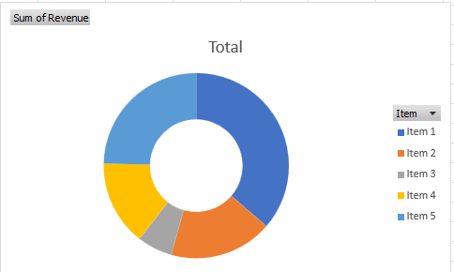

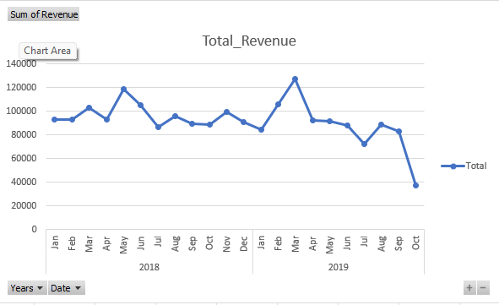

In today’s business environment, the tendency is towards Big Data. Managing and extracting real value from all that data is the key for modern business success. A well-designed dashboard is a remarkable information management tool.

Dashboard –Definition

Stephen Few has defined a dashboard as “a visual display of the most important information needed to achieve one or more objectives which fits entirely on a single computer screen so it can be monitored at a glance”. In the present terms, a dashboard can be defined as a data visualization tool that displays the current status of metrics and key performance indicators (KPIs) simplifying complex data sets to provide users with briefly awareness of current performance. Dashboards consolidate and arrange numbers and metrics on a single screen. They can be tailored for a specific role and display metrics of a department or an organization overall. Dashboards can be static for a one-time view, or dynamic showing the consolidated results of the data changes behind the screen. They can also be made interactive to display the various segments of large data on a single screen.

1. Objective /Scope of Analyse

Key Metrics for Dashboard

The core of the dashboard lies in the key metrics required for monitoring. Thus, based on whether the dashboard is for an organization overall or for a department such as sales, finance, human resources, production, etc. the key metrics that are required for display vary. Further, the key metrics for a dashboard also depend on the role of the recipients (audience). For example, Executive (CEO, CIO, etc.), Operations Manager, Sales Head, Sales Manager, etc. This is since the primary goal of a dashboard in to enable data visualization for decision making. The success of a dashboard often depends on the metrics that were chosen for monitoring. For example, Key Performance Indicators, Balanced Scorecards and Sales Performance Figures could be the content appropriate in business dashboards.

Dashboard Benefits

Dashboards allow managers to monitor the contribution of the various departments in the organization. To monitor the organization’s overall performance, dashboards allow you to capture and report specific data points from each of the departments in the organization, providing a snapshot of current performance and a comparison with earlier performance. Benefits of dashboards include the following –

• Visual presentation of performance measures.

• Ability to identify and correct negative trends.

• Measurement of efficiencies/inefficiencies.

• Ability to generate detailed reports showing new trends.

• Ability to make more informed decisions based on collected data.

• Alignment of strategies and organizational goals.

• Instant visibility of all systems in total.

• Quick identification of data outliers and correlations.

• Time saving with the comprehensive data visualization as compared to running multiple reports.

Types of Dashboards

Dashboards can be categorized based on their utility as follows –

• Strategic Dashboards

• Analytical Dashboards

• Operational Dashboards

• Informational Dashboards

Strategic Dashboards

Strategic dashboards support managers at any level in an organization for decision making. They provide the snapshot of data, displaying the health and opportunities of the business, focusing on the high-level measures of performance and forecasts.

• Strategic dashboards require to have periodic and static snapshots of data (e.g., daily, weekly, monthly, quarterly and annually). They need not be constantly changing from one moment to the next and require an update at the specified intervals of time.

• They portray only the high-level data not necessarily giving the details.

• They can be interactive to facilitate comparisons and different views in case of large data sets at the click of a button. But it is not necessary to provide more interactive features in these dashboards.

Analytical Dashboards

Analytical dashboards include more context, comparisons, and history. They focus on the various facets of data required for analysis. Analytical dashboards typically support interactions with the data, such as drilling down into the underlying details and hence should be interactive. Examples of analytical dashboards include Finance Management dashboard and Sales Management dashboard.

Operational Dashboards

Operational dashboards are for constant monitoring of operations. They are often designed differently from strategic or analytical dashboards and focus on monitoring of activities and events that are constantly changing and might require attention and response at a moment's notice. Thus, operational dashboards always require live and up to date data available and hence should be dynamic. An example of an operation dashboard could be a support-system dashboard, displaying live data on service tickets that require an immediate action from the supervisor on high priority tickets.

Informational Dashboards

Informational dashboards are just for displaying figures, facts and/or statistics. They can be either static or dynamic with live data but not interactive. For example, flights arrival/departure information dashboard in an airport.

3.Source of Dataset

Dashboard Data and Formats

The data required for a dashboard depends on its category. The premise for the data is that it should be relevant, error-free, up to date and live if required. The data can possibly be from various and different sources and formats (Spreadsheets, Text Files, Web Pages, Organizational Database, etc.). The results displayed on a dashboard must be authentic, correct and apt. This is crucial since the information on a dashboard would lead to decisions, actions and/or inferences. Thus, along with the data being displayed, the medium chosen for the display is equally important as it should not give an erroneous impression in the data portrayal. The focus should be on the ability of the data visualization that would unambiguously project the conclusions.

Live Data on Dashboards

As discussed earlier in this chapter, data warehousing and online analytical processing (OLAP) is making it possible to refresh the dynamic dashboards instantly with live data. It is also making those who design the dashboards be independent of the organization’s IT department for obtaining data. Thus, the dashboards have become the most sought-after medium from top management to a regular user.

4.ETL Process

Excel Tables

The most important component of any dashboard is its data. The data can be from a single source or multiple sources. The data might be limited or might span several rows. Excel tables are well suited to get the data into the workbook, in which you want to create the dashboard. There are several ways to import data into Excel, by establishing connections to various sources. This makes it possible to refresh the data in your workbook whenever the source data gets updated. You can name the Excel tables and use those names for referring your data in the dashboard. This would be easier than referring the range of data with cell references. These Excel tables are your working tables that contain the raw data. You can arrive at a summary of the analysis of data and portray the same in an Excel table that can be included as a part of a dashboard.

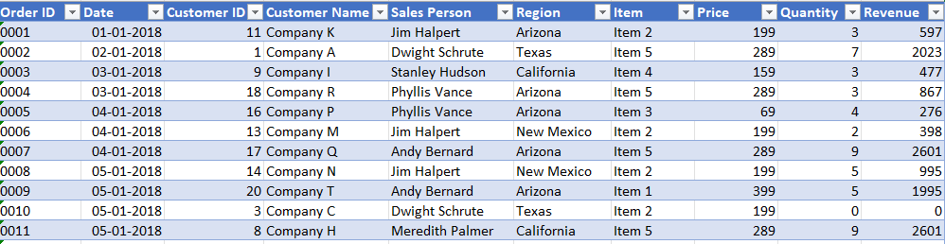

Sparklines

You can use Sparklines in your Excel tables to show trends over a period. Sparklines are mini charts that you can place in single cells. You can use line charts, column charts or win-loss charts to depict the trends based on your data.

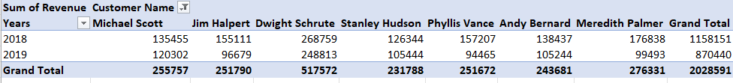

Conditional Formatting

Conditional formatting is a big asset to highlight data in the tables. You can define the rules by which you can vary color scales, data bars and/or icon sets. You can either use the Excel defined rules or create your own rules, based on the applicability to your data.

Excel Charts

Excel charts are the most widely used data visualization components for dashboards. You can get the audience view the data patterns, comparisons and trends in data sets of any size strikingly adding color and styles. Excel has several built-in chart types such as line, bar, column, scatter, bubble, pie, doughnut, area, stock, surface and radar if you have Excel 2013.

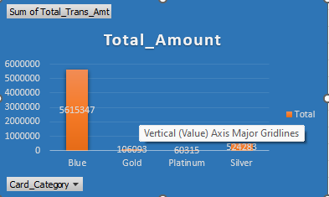

You will understand how to use these charts and the chart elements effectively in your dashboard in the chapter ─ Excel Charts for Dashboards. In addition to the above-mentioned chart types, there are other widely used chart types that come handy in representing certain data types. These are Waterfall Chart, Band Chart, Gantt chart, Thermometer Chart, Histogram, Pareto Chart, Funnel Chart, Box and Whisker Chart and Waffle Chart.

Excel Camera

Once you create charts, you need to place them in your dashboard. If you want to make your dashboard dynamic, with the data getting refreshed each time the source data changes, which is the case with most of the dashboards, you would like to provide an interface between the charts in your dashboard and the data at the backend. You can achieve this with the Camera feature of Excel.

Excel PivotTables

When you have large data sets and you would like to summarize the results dynamically showing various facets of the analysis results, Excel PivotTables come handy to include in your dashboard. You can use either the Excel tables or the more powerful data tables in the data model to create PivotTables. The main differences between the two approaches are – Excel Tables Data Tables Data from only one table can be used to create PivotTable. Data from more than one table can be used to create PivotTable, defining relationships between the tables. When the tables increase in the no. of rows, the memory handling and storage will not be optimistic. Can handle huge data sets with thousands of rows of data with memory optimization and decreased file size. If you try to create a PivotTable with more than one Excel table, you will be prompted to create relationship and the tables with the relationship get added to the data model.

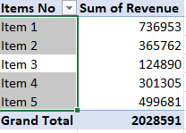

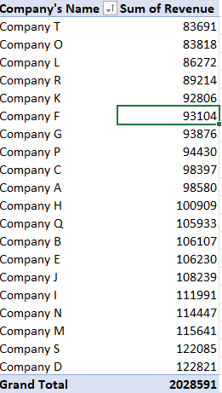

Excel Power PivotTables and Power Pivot Charts

Excel Power PivotTables and Power Pivot Charts are helpful to summarize data from multiple resources, by building a memory optimized Data Model in the workbook. The Data Tables in the Data Model can run through several thousands of dynamic data enabling summarization with less effort and time. You will learn about the usage of Power PivotTables and Power Pivot Charts in dashboards in the chapter - Excel Power PivotTables and Power Pivot Charts for Dashboards.

Excel Power View Reports

Excel Power View Reports provide interactive data visualization of large data sets bringing out the power of Data Model and interactive nature of dynamic Power View visualizations. You will learn about how to use Power View as dashboard canvas in the chapter - Excel Power View Reports for Dashboards.

Key Performance Indicators (KPIs)

Key Performance Indicators (KPIs) are integral part of many dashboards. You can create and manage KPIs in Excel. You will learn about KPIs in the chapter ─ Key Performance Indicators in Excel Dashboards.

5.Analyze on Dataset

Introduction:

Data visualization is an aid in understanding the data provided by placing visual context or a graphical representation. It provides the ability to easily identify the connections among multi-dimensional datasets. It allows individuals to directly interact with the data and comprehend information quicker. It provides them an accessible way to understand emerging trends in both business and in the market. It aids to spot outliers that may affect the overall business. Data visualization aids to recognize correlated parameters and identify factors that could affect the overall business goals (SAS, 2020). Managers incorporate visual, text, and verbal communication to aid their target audience in understanding their message. A study conducted (Horn, 2001) a business study on the effect of data visualization and lead to the following conclusions:

• When written information is combined with visualizations, it is 70% more memorable.

• Solving problems are more effective by 19%

• Visualizations produce 22% higher results

• Time is producing results were lessened by 13%.

Data visualization can help different financial institution in decision making. In this study, we would be focusing on the sales in one of the financial institutions in the world. This study focuses on creating a platform containing the key-indicators that will provide insight into the business to create strategies and business decisions in sales of a Company. With the creation of data visualizations on their current credit card sales, it will aid the business to monitor the sales applications and create insights and strategies. The financial institution for this study has a Business Intelligence team that is responsible for providing reports on their sales to the sales agent. Currently, their reports are manually processed in Microsoft Excel where their data is sourced in SAS. With their current manual process, their credit card sales report is cumbersome and could lead to discrepancies in doing their calculations that could cause inaccuracies in their recommendations for the sales team

The creation of data visualization aims to aid the sales agent to identify the following marketing strategies:

• Focus on the performing markets: the dashboard aims to identify the best- performing markets where they could get more customers that are capable of avail of their products and services. The dashboard will highlight the following factors:

• Channels of sales Application: this shows the different sources that aided the customer with their sales application. The sales agent could then determine which channels had the most applications for them to capitalize.

• Branches: the sales agents are deployed to branches to sell products to potential customers. They aim to determine the performing branches to allocate the right number of staff to perform direct sales to customers. They could then focus on the locations that will get more customers such as mall branches, office buildings, and other commercial establishments.

• Cross-Tabulation: the cross-tabulation matrix aims to identify the right offer to the right market by identifying the quantitative relationship of different variables.

• Focus on the best performing offers: the dashboard aims to identify the most marketable and performing products/services to the customers. This aims to aid the business to strategize in the matching of their product/service to their customers. The business aims to have products that can cater to every customer by identifying their needs and behaviours.

• Maintain and improve their sales performance: the dashboard aims to identify key indicators that will provide ideas to the business to improve their performance in sales. They compare their current performance with their previous performance and then formulate strategies to improve their future sales. The project includes all decided sales applications that pass through around the country. The scope of the project covers data including customer information and their banking information and credit information. The dashboard itself would mainly focus on the count of applications per profile.

Methodology

The researchers were guided by the process workflow as shown in Figure 1. Proceedings of the 11th Annual International Conference on Industrial Engineering and Operations Management Singapore. Project Workflow 3.1 Presentation of the Business Case from the Client

1. Problem Statement of the Project: The client presented their current projects from the Business Intelligence team. The project focuses on the sales dashboard. They currently use Microsoft Excel. They extract the data from the source and create a report that is viewed by the sales agent. As the data grows, the amount of Excel reports increases which makes it more difficult to create insights.

2. Project Objectives: The client presented the objectives of the Credit Card Sales team. They provided the metrics that they monitor in the reports provided by the Business Intelligence team. The business needs a platform to monitor if the Sales team is aligned with the larger business objectives.

3. Scope of the Project: The client presented the scopes and limitations of the sales report. The client also indicated that the data sharing policy is very strict thus they only provided the field names of the data and suggested using dummy data for the project.

3.2 Data Gathering

1. Assess the support needed in getting the data: The client shared their knowledge in the current sales report. The client discussed the data file structure that contained all the field names of the data and provided the list of the field names that the Business Intelligence team used in creating the report. The Business Intelligence team discussed the workaround of a dummy dataset.

2. Gather the data file structure from the client: The business sent out the data file structure for Sales. The definition of each column field was also indicated to identify which are useful for the sales reports. Possible scenarios/values were also shared by the team for some of the column fields. Proceedings of the 11th Annual International Conference on Industrial Engineering and Operations Management Singapore.

3. Gathering of data fields needed for the project: The proponent discussed the column fields that will be used for the dashboard creation. The selection of the column fields is based on the definition provided by the client.

4. Generate mock data: A web application will be used to generate random data that is in-line with the data dictionary for the sales report.

5. Data quality check: The Business Intelligence team will validate if the data has the correct formatting and if it is logical for the dashboard.

3.3 Data Analysis Data Exploratory Analysis: Descriptive analysis was done to the data which is in-line with the goals of the project. The proponent explored the column fields and confirmed with the client if the analysis aligns with the objectives of the Sales team.

3.4 Solutions Creation of the dashboard: The proponent developed the dashboard that was agreed with the Business Intelligence team using Microsoft Power BI (Free Version).

3.5 Solutions Validation of the Dashboard: The client will check the dashboard if it aligns with the proposed design and validates if the data and dashboard are displaying the correct data using the mock data created. The Sales team validates the dashboard if it is aligned with their objectives.

3.6 Finalize Project The dashboard will be turned over to the Business Intelligence team and will sign-off the project.

4.Results and Discussion

The objective of the project is to create a platform that will aid sales agents to accomplish their business objectives using the count of customers as their primary metric. The researcher determined first the current workflow of the financial institution. The current workflow will guide the researcher on how to create the data visualization.

4.1 Sales Team Current Workflow The credit card sales team receives reports from the Business Intelligence Team. The Business Intelligence Team extracts the data from the source and creates reports in excel format. The reports generated contain the list of the applicants, detailed information of the applicants, the detailed information about the product they applied for, and the channel of their applications. The sales team then checks these reports and create insights from these reports by checking the following metrics:

• Performing Branches: Most of the applicants are from direct sales where the applicant walks-in to their branches to apply for services. The sales team identifies which branches had more applicants which will also require more deployed direct sales agents to be able to process more applications.

• Performing Brands/Products: the sales team identifies which among their brands and products should capitalize to get more approved customers.

• Performing Customers: the sales team monitors the information on each applicant such as their residential address, employment status, age, and marital status for them to strategize their branch locations and their availability of their brands/products. They also want to focus on getting more customers by capitalizing on newto-credit customers. Proceedings of the 11th Annual International Conference on Industrial Engineering and Operations Management Singapore, March 7-11, 2021. Overview of the Dashboard - The page shows a high-level summary of the credit card sales performance. It contains the following visualizations:

• Sales profile by Brand: this visualization monitors the number of applications of sales per brand.

• Sales profile by Product: this visualization monitors the number of applications of each product type.

• Sales profile by Channel: this visualization monitors the channels that a customer was referred to avail for their credit cards.

• Total count of approved credit card applications: these visualizations track the total approved Sales applications per month and year-to-date figures.

• Total count of rejected Sales applications: these visualizations track the total rejected Sales applications per month and year-to-date figures.

• The approval rate of credit card applications: this visualization tracks the overall approval rate of their sales.

• Second Card Rate: these visualizations show the percentage of the approved customers to obtain another Sales.

• Total count of the Carded/Non-Carded Sales services: this visualization shows the count of carded and non-carded credit applications.

• New to Sales application rate: this visualization shows new applicants for the Sales.

• Sales profile by Branch: this visualization monitors the card sales activities for each Branch.

• Rejected Sales application table: this visualization monitors the reasons for rejected applicants for their Sales.

• Year-on-Year Comparison of credit card sales: this visualization monitors the sales comparison of credit cards. Customer Demographics Dashboard - The page shows the analysis of the customer profiles who applied for the credit Sales:

• Customer by Employment Years: this visualization monitors the count of customers in their years of employment.

• Customer by Net Income: this visualization monitors the count of customers in their Net Income.

• Monthly Customer Count: this visualization monitors the total number of customers and their Employee Type monthly.

• Customer by Education: this visualization monitors the count of customers in their Educational Attainment.

• Customer Residential Address Map: this visualization displays a map of customer count per residential address.

• Customer Residential Address Table: this visualization monitors the count of customers per residential address.

• Approval Rate: the visualization shows the approval rate of the customers.

• Approved/Rejected Count: this visualization shows the count of approved and rejected customers.

• Employed/Unemployed Count: this visualization shows the count of Employed and Unemployed customers.

• New to Sales Count: this visualization shows the count of new-to-Sales customers.

4.2 Sales Dashboard New Workflow Sales Performance Overview. The dashboard displays the overview performance of the dashboard. The credit card sales team will be able to monitor the overall sales performance on one page. Sales will be able to determine which product Brand and products marketable. They can determine which Branches are performing and be able to strategize their deployment of direct sales agents. The Sales team can briefly check now the count of customers that are approved, rejected, new applicants, applicants that will be granted another card, and the reasons the applicants were rejected. Customer Demographics Dashboard. The dashboard displays customer information that will aid them in decision making. They can identify the type of applicant who applies for which product. They will be able to identify which Proceedings of the 11th Annual International Conference on Industrial Engineering and Operations Management Singapore, March 7-11, 2021. International 6862 branches should be put to focus because there are more applicants which have a residence address or work address near their branches. Cross-Tabulation Page. The credit card sales team will be able to create more analysis and comparisons by crosstabulation between charts and dashboard pages. This functionality reveals additional details of the charts and displays additional records that contain specific characteristics described from other charts. The Cross-Tabulation is in a matrix table that can expand their rows or columns to identify quantitatively the relationship of multiple variables.

4.3 Dashboard for Visualization The generated data are loaded to a dashboarding tool (Microsoft PowerBI) and create the report in which we would determine if it were in line with the objectives. The date is filtered from January 1, 2018, to the latest data to get the comparison of the sales performance from the current year (2019) to last year (2018). The results displayed in Credit Card Sales Performance Overview are using mocked up data. Credit Card Sales Performance Overview Figure 2. Credit Card Sales Performance Overview Figure 2 shows the Overview Dashboard of the credit card sales performance. This displays the figures which they are primarily monitoring. The business would like to monitor the count of the applicants (approved or rejected). The overview dashboard displays the overall count of applicants in different profiles.

Visualization



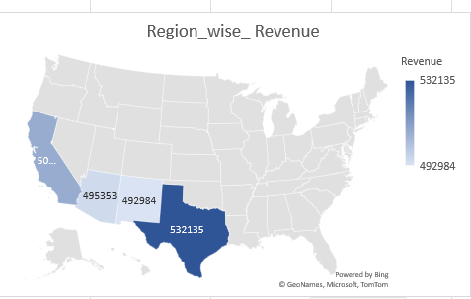



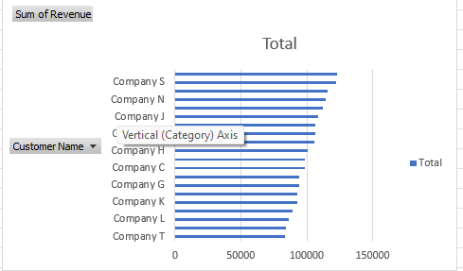

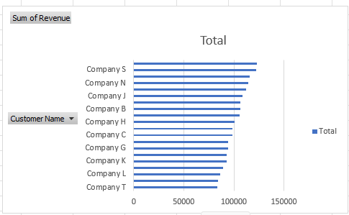

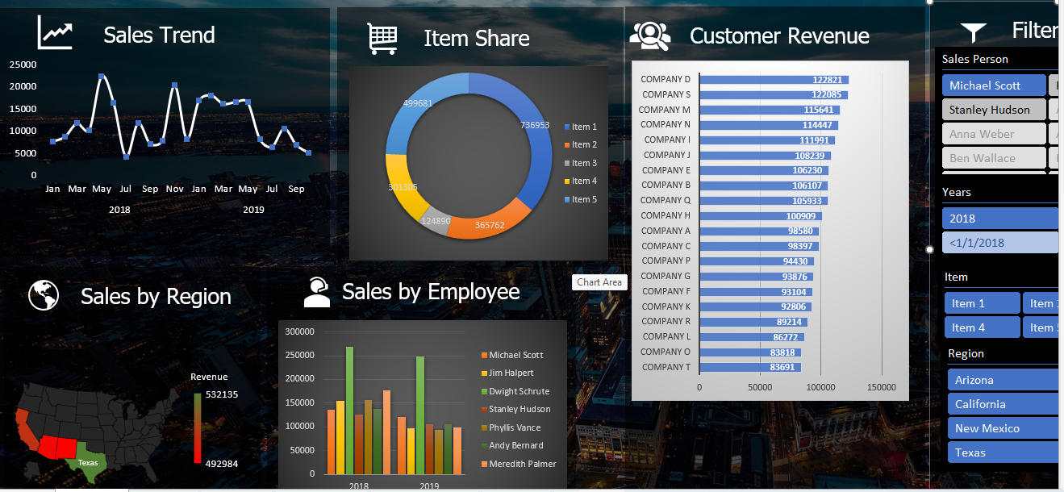

7.Refrences

Data Visualization: What it is and why it matters, Available: ttps://www.sas.com/en_ph/insights/big-data/datavisualization.html, 2019 Horn, R., Visual Language and Converging Technologies in the Next 10-15 Years (and beyond), 2011. Shukla, A., and Dhir, S., Tools for Data Visualization in Business Intelligence: Case Study Using the Tool QlikView. Proceedings of Third International Conference India 2016, vol. 2, DOI: 10.1007/978-81-322-2752- 6_31, 2016. Diamond, J., and Mattia, A., Data visualization: an exploratory study into the software tools used by Businesses, Journal of Instructional Pedagogies, vol. 17, 2019 Dupin-Bryant, P., and Olsen, D., Business Intelligence, Analytics and Data Visualization: A Heat Map Project Tutorial, International Journal of Management & Information Systems, vol. 18, Number 3. 2014

8.Bibliography

a) Google: Kaggle.com, ieomsociety.com

b) YouTube: tutorials Point